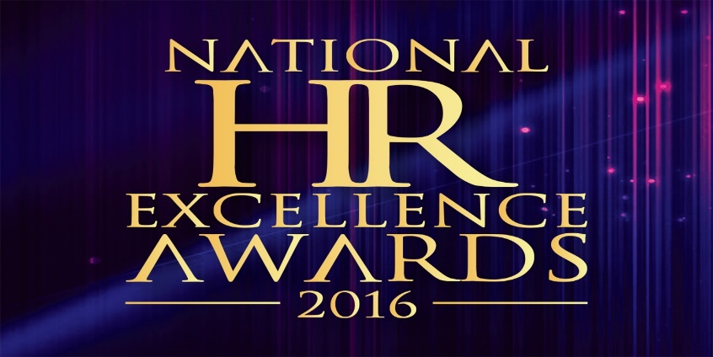

**Institute Of Personnel Management Sri Lanka - National Human Resource Awards 2016   
Questionnaire to be completed by Prospective Applicants**

|  |  |
| --- | --- |
| 1. **Does your organization have a HR policy?** |  |
| 1. **When was the HR policy approved by the board?** |  |
| 1. **Does your organization have a manpower plan?** |  |
| 1. **Does your organization have a recruitment & selection policy?** |  |
| 1. **Does your organization conduct job analysis?** |  |
| 1. **Does your organization have job specifications & Job Descriptions?** |  |
| 1. **Does your organization carry out job evaluations?** |  |
| 1. **Does your organization have a job grading system?** |  |
| 1. **Does your organization have a reward management scheme?** |  |
| 1. **Does your organization have a performance management system?** |  |
| 1. **Does your organization have a training & development policy?** |  |
| 1. **What is your annual training budget? (State in SLR)** |  |
| 1. **Does your organization have an employee relations policy and process?** |  |
| 1. **Does your organization have a health, safety & welfare Policy?** |  |
| 1. **Does your organization have an industrial relations system?** |  |
| 1. **Does your organization have a formal disciplinary procedure?** |  |
| 1. **Is your organization unionized?** |  |
| 1. **Do you have joint consultative council?** |  |
| 1. **Does your organization have an open communication system?** |  |
| 1. **Is your performance management system online?** |  |
| 1. **Does your organization have a human resource information system (HRIS)?** |  |
| 1. **Do you practice formal career management?** |  |
| 1. **Does your organization have a succession plan?** |  |
| 1. **Does your organization have a superannuation scheme?** |  |
| 1. **Do you have a formal grievance handling procedure?** |  |
| 1. **Does your organization conduct employee engagement surveys?** |  |
| 1. **Does your organization conduct HR audits periodically?** |  |
| 1. **Does your HR Department have a HR scorecard?** |  |
| 1. **Does your organization practice formal goal setting covering the CEO downwards?** |  |
| 1. **Does your organization have a formal Policy on organizational productivity?** |  |
| 1. **Does your organization have code of ethics?** |  |
| 1. **Does your organization have a value statement?** |  |
| 1. **Does your organization have a strategic plan for the next 5 years?** |  |
| 1. **What was your employee turnover percentage in year 2015?** |  |

We certify that the information furnished herein is true and correct.

………………………………………. …………………………………………………………..  
 **Signature of CEO** **Name of CEO**

**Date**: